File: students_data.csv
Student_ID,Name,Department,Year,Math_Score,Science_Score,English_Score,Join_Date
1,Student_1,CE,4,64.0,69.0,73.0,2021-01-01
2,Student_2,EEE,3,99.0,71.0,73.0,2021-01-16
3,Student_3,ME,4,99.0,81.0,49.0,2021-01-31
4,Student_4,EEE,3,99.0,48.0,59.0,2021-02-15
5,Student_5,EEE,4,84.0,37.0,40.0,2021-03-02
6,Student_6,ECE,1,80.0,35.0,87.0,2021-03-17
7,Student_7,ME,4,68.0,39.0,84.0,2021-04-01
8,Student_8,ME,3,,60.0,57.0,2021-04-16
9,Student_9,ME,3,84.0,89.0,,2021-05-01
10,Student_10,EEE,2,,48.0,,2021-05-16
11,Student_11,CE,1,64.0,73.0,62.0,2021-05-31
12,Student_12,ME,4,46.0,61.0,30.0,2021-06-15
13,Student_13,EEE,2,48.0,,86.0,2021-06-30
14,Student_14,ECE,4,63.0,49.0,56.0,2021-07-15
15,Student_15,CE,4,40.0,49.0,86.0,2021-07-30
16,Student_16,ECE,2,83.0,60.0,81.0,2021-08-14
17,Student_17,CE,2,47.0,,42.0,2021-08-29
18,Student_18,EEE,2,63.0,94.0,70.0,2021-09-13
19,Student_19,CSE,2,50.0,47.0,32.0,2021-09-28
20,Student_20,CE,2,90.0,85.0,68.0,2021-10-13
21,Student_21,ECE,4,56.0,66.0,35.0,2021-10-28
22,Student_22,EEE,2,47.0,73.0,37.0,2021-11-12
23,Student_23,CE,1,74.0,83.0,56.0,2021-11-27
24,Student_24,CSE,3,74.0,86.0,,2021-12-12
25,Student_25,CSE,2,72.0,66.0,66.0,2021-12-27
26,Student_26,ME,2,98.0,38.0,62.0,2022-01-11
27,Student_27,ME,4,44.0,64.0,80.0,2022-01-26
28,Student_28,ECE,2,81.0,71.0,71.0,2022-02-10
29,Student_29,CE,2,78.0,,73.0,2022-02-25
30,Student_30,CE,2,,73.0,53.0,2022-03-12
31,Student_31,ME,4,,79.0,44.0,2022-03-27
32,Student_32,CE,2,67.0,49.0,,2022-04-11
33,Student_33,CE,3,46.0,77.0,83.0,2022-04-26
34,Student_34,CSE,4,48.0,63.0,61.0,2022-05-11
35,Student_35,ME,3,47.0,70.0,61.0,2022-05-26
36,Student_36,EEE,4,51.0,,53.0,2022-06-10
37,Student_37,ME,2,73.0,66.0,70.0,2022-06-25
38,Student_38,EEE,3,72.0,41.0,,2022-07-10
39,Student_39,CSE,4,87.0,93.0,78.0,2022-07-25
40,Student_40,ECE,1,,85.0,78.0,2022-08-09
41,Student_41,CE,2,62.0,56.0,87.0,2022-08-24
42,Student_42,CSE,4,63.0,62.0,81.0,2022-09-08
43,Student_43,CE,1,76.0,36.0,41.0,2022-09-23
44,Student_44,ECE,4,74.0,76.0,68.0,2022-10-08
45,Student_45,ECE,1,83.0,79.0,31.0,2022-10-23
46,Student_46,CSE,2,79.0,91.0,32.0,2022-11-07
47,Student_47,ECE,3,61.0,87.0,78.0,2022-11-22
48,Student_48,EEE,1,66.0,40.0,66.0,2022-12-07
49,Student_49,ECE,4,74.0,,78.0,2022-12-22
50,Student_50,CE,2,40.0,62.0,85.0,2023-01-06

CODE:
import pandas as pd
df = pd.read_csv('students_dataset.csv') #Loading
print(df.head()) #Print
print(df.info())
print(df.describe(include='all'))
OUTPUT:
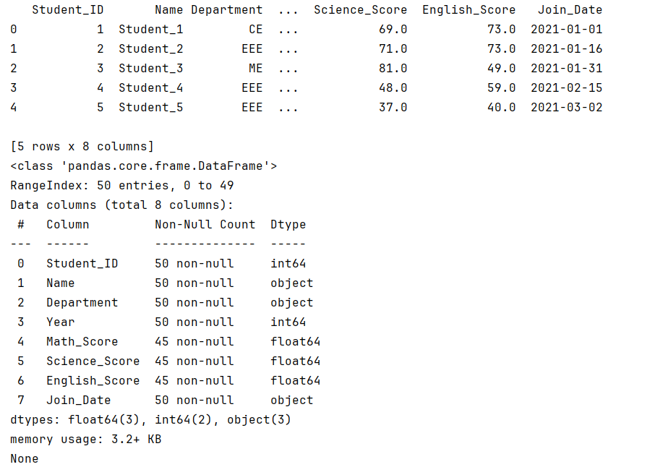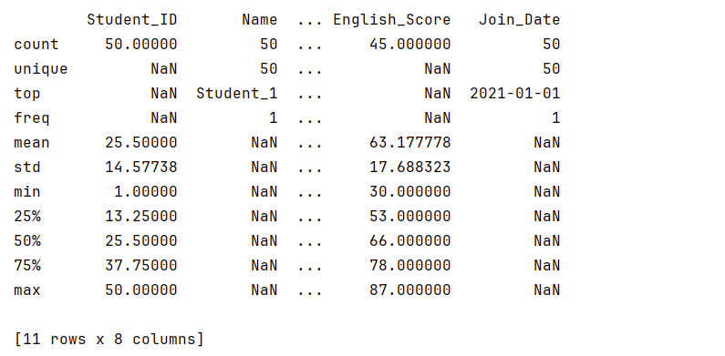

CODE:
import pandas as pd
df = pd.read_csv('students_dataset.csv') #Loading
print(df.isnull().sum())
cse_students = df[df['Department'] == 'CSE']
print(cse_students)
third_year_scores = df[df['Year'] == 3][['Name', 'Math_Score']]
print(third_year_scores)
first_10_rows = df.iloc[:10]
print(first_10_rows)
students_10_to_20 = df.loc[10:20]
print(students_10_to_20)
students_10_to_20 = df.loc[(df['Student_ID'] >= 10) & (df['Student_ID'] <= 20)]
print(students_10_to_20)
students_10_to_20 = df.loc[(df['Student_ID'] >= 10) & (df['Student_ID'] <= 20)]
print(students_10_to_20)

OUTPUT:
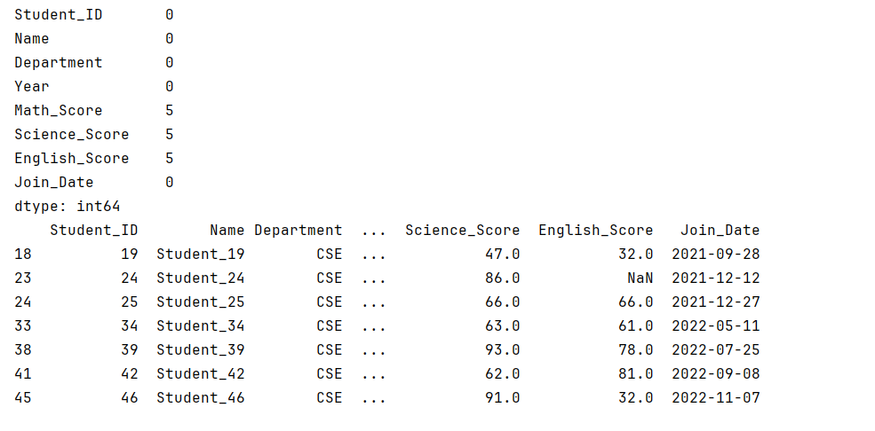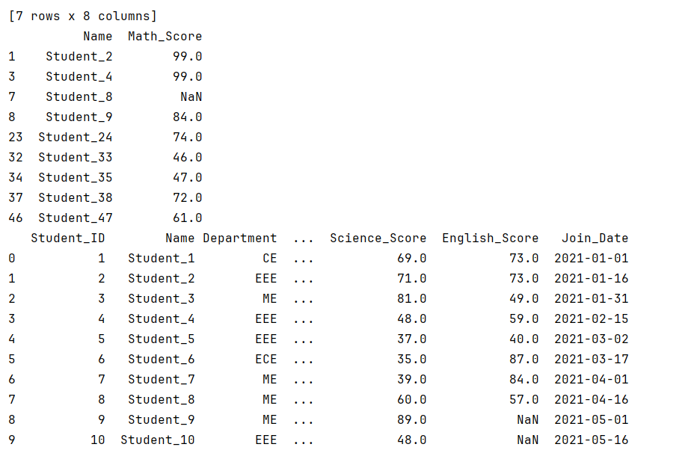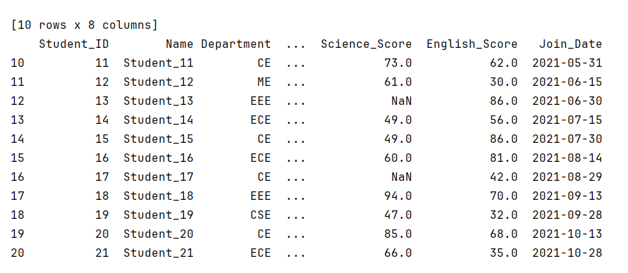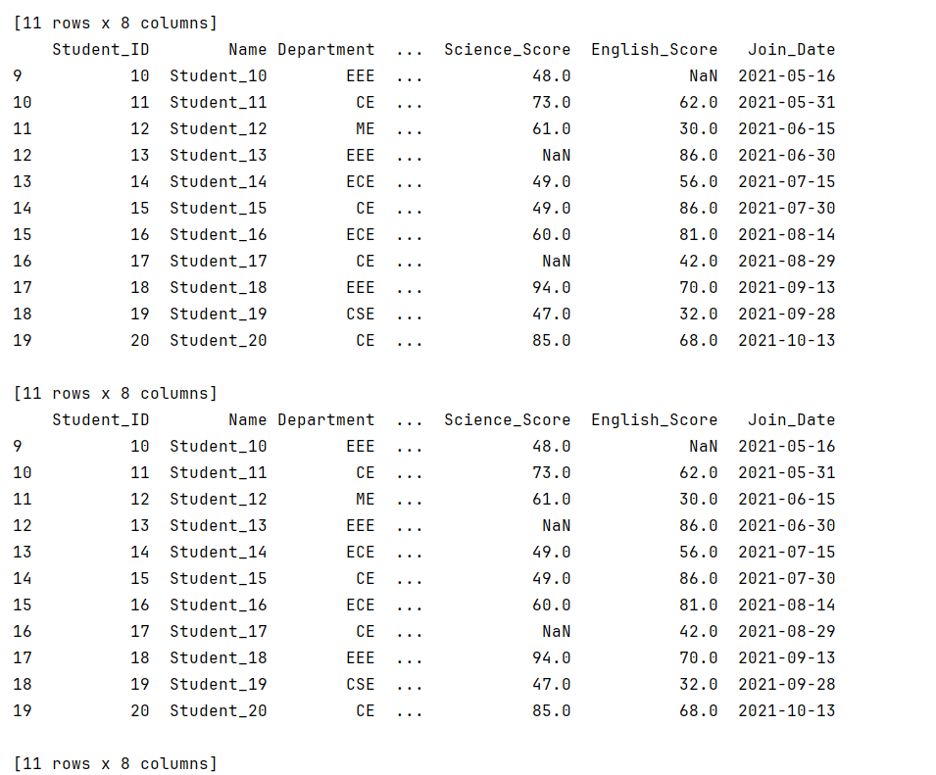

CODE:
import pandas as pd
df = pd.read_csv('students_dataset.csv') #Loading
average_math_score = df['Math_Score'].mean()
print("Average Math score =", average_math_score)
science_score_by_dept = df.groupby('Department')['Science_Score'].mean()
print("Science score by Dept =\n", science_score_by_dept)
students_per_year = df['Year'].value_counts()
print("Students per year =\n", students_per_year)
students_per_year = df.groupby('Year').size()
print("Students per year(Sorted) =\n", students_per_year)
avg_english_by_dept = df.groupby('Department')['English_Score'].mean()
top_department = avg_english_by_dept.idxmax()
print("Top Dept in English =", top_department)
OUTPUT:
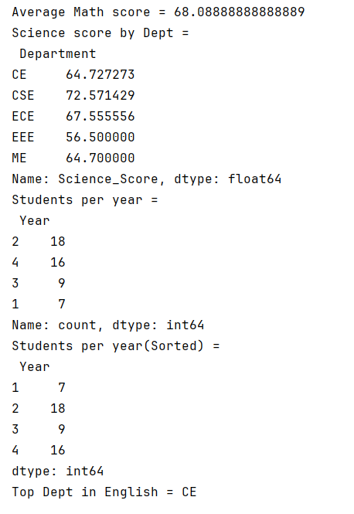
CODE:
import pandas as pd
df = pd.read_csv('students_dataset.csv')
# 18. Convert Join_Date to datetime if not already
df['Join_Date'] = pd.to_datetime(df['Join_Date'])
# 19. Sort students by Join_Date in ascending order
sorted_df = df.sort_values(by='Join_Date')
# 20. Find how many students joined in the year 2022
# Extract year from Join_Date and filter
joined_2022_count = df[df['Join_Date'].dt.year == 2022].shape[0]
# 21. Extract the month name of Join_Date into a new column
df['Join_Month'] = df['Join_Date'].dt.month_name()
# Display results
print("Sorted Students by Join_Date:")
print(sorted_df[['Name', 'Join_Date']].head()) # show first few sorted entries
print(f"\nNumber of students joined in 2022: {joined_2022_count}")
print("\nData with Join_Month column added:")
print(df[['Name', 'Join_Date', 'Join_Month']].head())
OUTPUT:
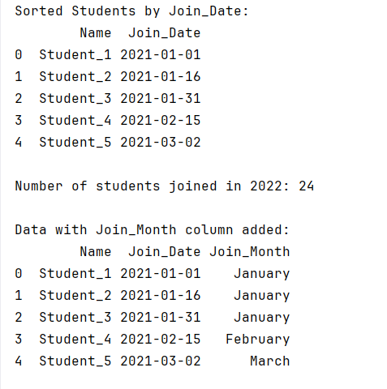
CODE:
import pandas as pd
from datetime import datetime
df = pd.read_csv('students_dataset.csv')
# Convert Join_Date to datetime
df['Join_Date'] = pd.to_datetime(df['Join_Date'])
# 22. Create Total_Score as sum of Math_Score, Science_Score, English_Score
df['Total_Score'] = df[['Math_Score', 'Science_Score', 'English_Score']].sum(axis=1, skipna=True)
# 23. Create Average_Score = Total_Score / 3
df['Average_Score'] = df['Total_Score'] / 3
# 24. Add Grade column based on Average_Score
def assign_grade(avg):
if avg >= 75:
return 'A'
elif avg >= 60:
return 'B'
else:
return 'C'
df['Grade'] = df['Average_Score'].apply(assign_grade)
# 25. Save the cleaned & enriched dataset
df.to_csv('students_data_cleaned.csv', index=False)
# Optional: print first few rows to verify
print(df[['Name', 'Total_Score', 'Average_Score', 'Grade']].head())
OUTPUT:
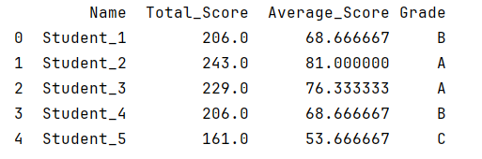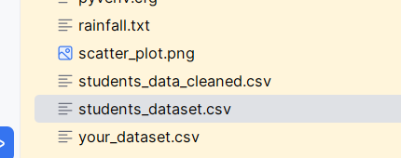

File: students_data_cleaned.csv
Student_ID,Name,Department,Year,Math_Score,Science_Score,English_Score,Join_Date,Total_Score,Average_Score,Grade
1,Student_1,CE,4,64.0,69.0,73.0,2021-01-01,206.0,68.66666666666667,B
2,Student_2,EEE,3,99.0,71.0,73.0,2021-01-16,243.0,81.0,A
3,Student_3,ME,4,99.0,81.0,49.0,2021-01-31,229.0,76.33333333333333,A
4,Student_4,EEE,3,99.0,48.0,59.0,2021-02-15,206.0,68.66666666666667,B
5,Student_5,EEE,4,84.0,37.0,40.0,2021-03-02,161.0,53.666666666666664,C
6,Student_6,ECE,1,80.0,35.0,87.0,2021-03-17,202.0,67.33333333333333,B
7,Student_7,ME,4,68.0,39.0,84.0,2021-04-01,191.0,63.666666666666664,B
8,Student_8,ME,3,,60.0,57.0,2021-04-16,117.0,39.0,C
9,Student_9,ME,3,84.0,89.0,,2021-05-01,173.0,57.666666666666664,C
10,Student_10,EEE,2,,48.0,,2021-05-16,48.0,16.0,C
11,Student_11,CE,1,64.0,73.0,62.0,2021-05-31,199.0,66.33333333333333,B
12,Student_12,ME,4,46.0,61.0,30.0,2021-06-15,137.0,45.666666666666664,C
13,Student_13,EEE,2,48.0,,86.0,2021-06-30,134.0,44.666666666666664,C
14,Student_14,ECE,4,63.0,49.0,56.0,2021-07-15,168.0,56.0,C
15,Student_15,CE,4,40.0,49.0,86.0,2021-07-30,175.0,58.333333333333336,C
16,Student_16,ECE,2,83.0,60.0,81.0,2021-08-14,224.0,74.66666666666667,B
17,Student_17,CE,2,47.0,,42.0,2021-08-29,89.0,29.666666666666668,C
18,Student_18,EEE,2,63.0,94.0,70.0,2021-09-13,227.0,75.66666666666667,A
19,Student_19,CSE,2,50.0,47.0,32.0,2021-09-28,129.0,43.0,C
20,Student_20,CE,2,90.0,85.0,68.0,2021-10-13,243.0,81.0,A
21,Student_21,ECE,4,56.0,66.0,35.0,2021-10-28,157.0,52.333333333333336,C
22,Student_22,EEE,2,47.0,73.0,37.0,2021-11-12,157.0,52.333333333333336,C
23,Student_23,CE,1,74.0,83.0,56.0,2021-11-27,213.0,71.0,B
24,Student_24,CSE,3,74.0,86.0,,2021-12-12,160.0,53.333333333333336,C
25,Student_25,CSE,2,72.0,66.0,66.0,2021-12-27,204.0,68.0,B
26,Student_26,ME,2,98.0,38.0,62.0,2022-01-11,198.0,66.0,B
27,Student_27,ME,4,44.0,64.0,80.0,2022-01-26,188.0,62.666666666666664,B
28,Student_28,ECE,2,81.0,71.0,71.0,2022-02-10,223.0,74.33333333333333,B
29,Student_29,CE,2,78.0,,73.0,2022-02-25,151.0,50.333333333333336,C
30,Student_30,CE,2,,73.0,53.0,2022-03-12,126.0,42.0,C
31,Student_31,ME,4,,79.0,44.0,2022-03-27,123.0,41.0,C
32,Student_32,CE,2,67.0,49.0,,2022-04-11,116.0,38.666666666666664,C
33,Student_33,CE,3,46.0,77.0,83.0,2022-04-26,206.0,68.66666666666667,B
34,Student_34,CSE,4,48.0,63.0,61.0,2022-05-11,172.0,57.333333333333336,C
35,Student_35,ME,3,47.0,70.0,61.0,2022-05-26,178.0,59.333333333333336,C
36,Student_36,EEE,4,51.0,,53.0,2022-06-10,104.0,34.666666666666664,C
37,Student_37,ME,2,73.0,66.0,70.0,2022-06-25,209.0,69.66666666666667,B
38,Student_38,EEE,3,72.0,41.0,,2022-07-10,113.0,37.666666666666664,C
39,Student_39,CSE,4,87.0,93.0,78.0,2022-07-25,258.0,86.0,A
40,Student_40,ECE,1,,85.0,78.0,2022-08-09,163.0,54.333333333333336,C
41,Student_41,CE,2,62.0,56.0,87.0,2022-08-24,205.0,68.33333333333333,B
42,Student_42,CSE,4,63.0,62.0,81.0,2022-09-08,206.0,68.66666666666667,B
43,Student_43,CE,1,76.0,36.0,41.0,2022-09-23,153.0,51.0,C
44,Student_44,ECE,4,74.0,76.0,68.0,2022-10-08,218.0,72.66666666666667,B
45,Student_45,ECE,1,83.0,79.0,31.0,2022-10-23,193.0,64.33333333333333,B
46,Student_46,CSE,2,79.0,91.0,32.0,2022-11-07,202.0,67.33333333333333,B
47,Student_47,ECE,3,61.0,87.0,78.0,2022-11-22,226.0,75.33333333333333,A
48,Student_48,EEE,1,66.0,40.0,66.0,2022-12-07,172.0,57.333333333333336,C
49,Student_49,ECE,4,74.0,,78.0,2022-12-22,152.0,50.666666666666664,C
50,Student_50,CE,2,40.0,62.0,85.0,2023-01-06,187.0,62.333333333333336,B

